**Financial Engineering Lab MA – 374 Lab – 7**

**Name –** Rasesh Srivastava

**Roll Number –** 210123072

**Branch –** Mathematics and Computing

Question 1:

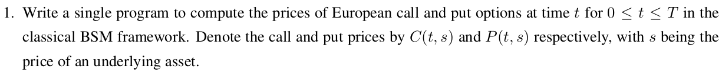

The prices of European call and put options at time t for 0 ≤t ≤T in the classical BSM framework is calculated by solving the Black-Scholes-Merton Partial Differential Equation.

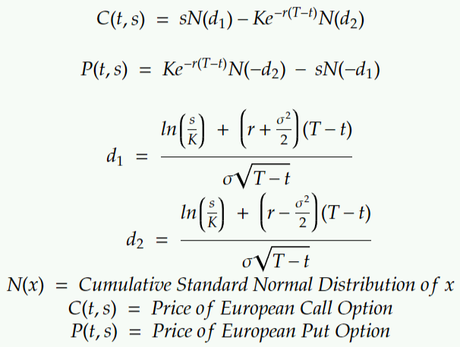

The program to compute the prices of European call and put options at time t for 0 ≤t ≤T in the classical BSM framework is as follows:

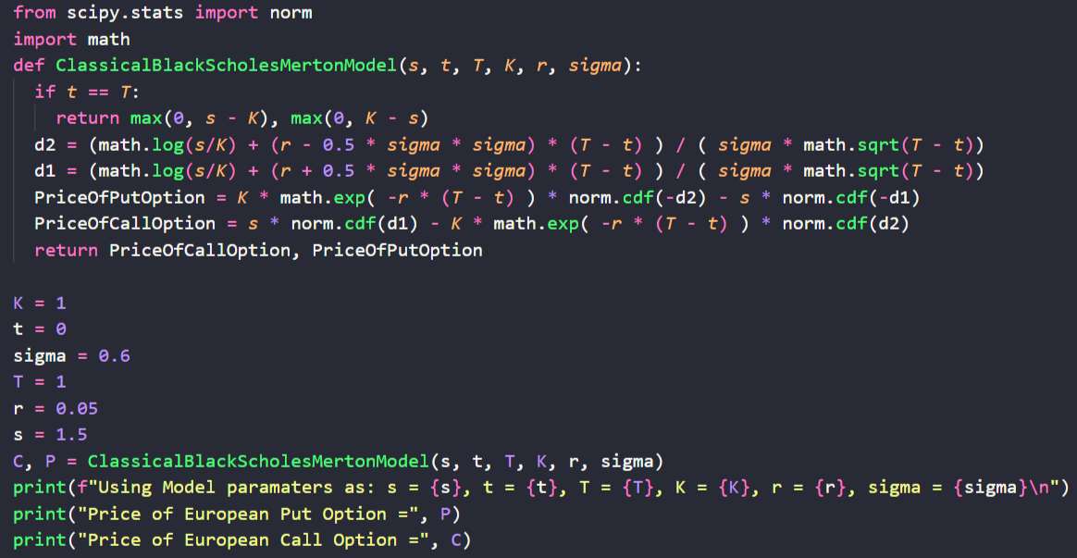

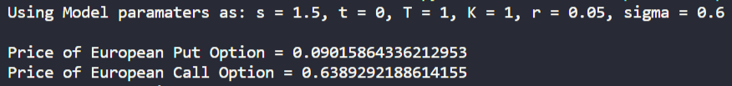

Question 2:



The graph of C(t,s) as a function of s is as follows:

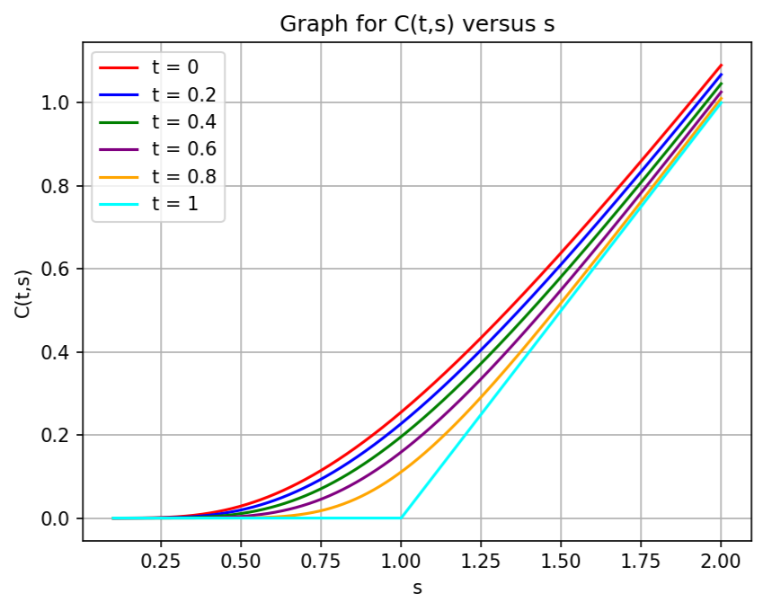

The graph of P(t,s) as a function of s is as follows:

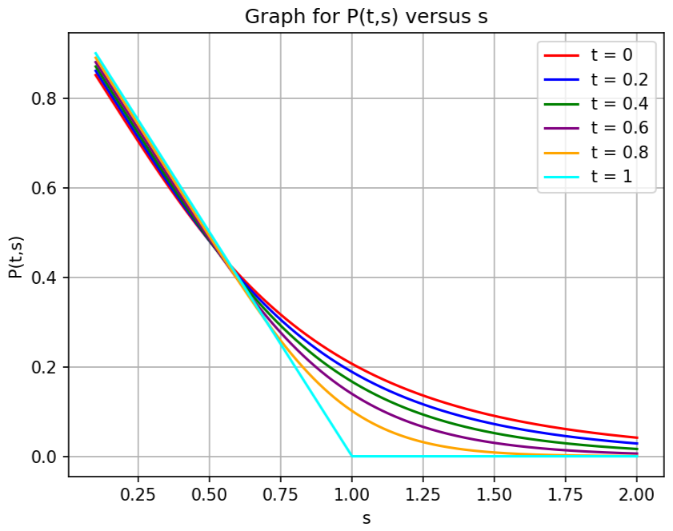

The graph of C(t,s) as a function of both t and s is as follows:

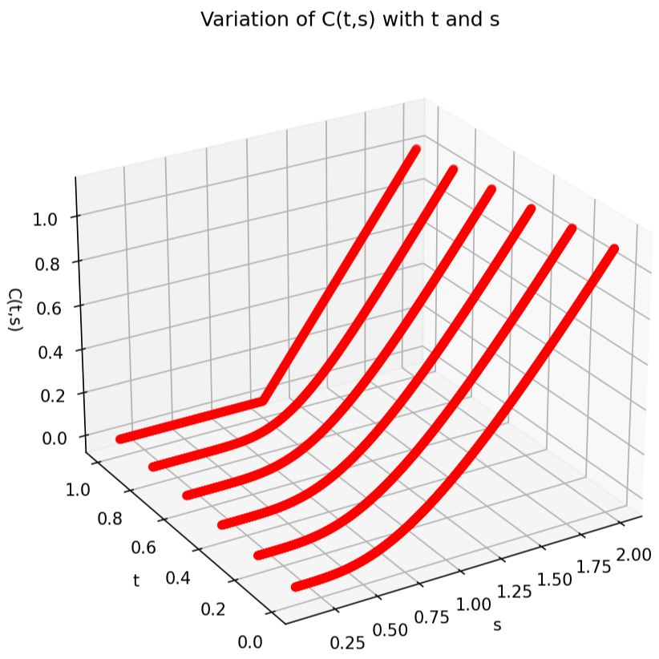

The graph of P(t,s) as a function of both t and s is as follows:

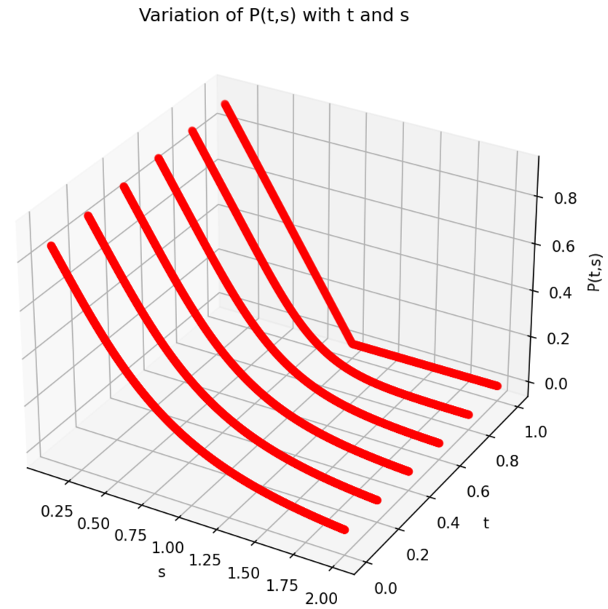

Question 3:



The plot of C(t, s) as a smooth surface above the (t, s)-plane is as follows:

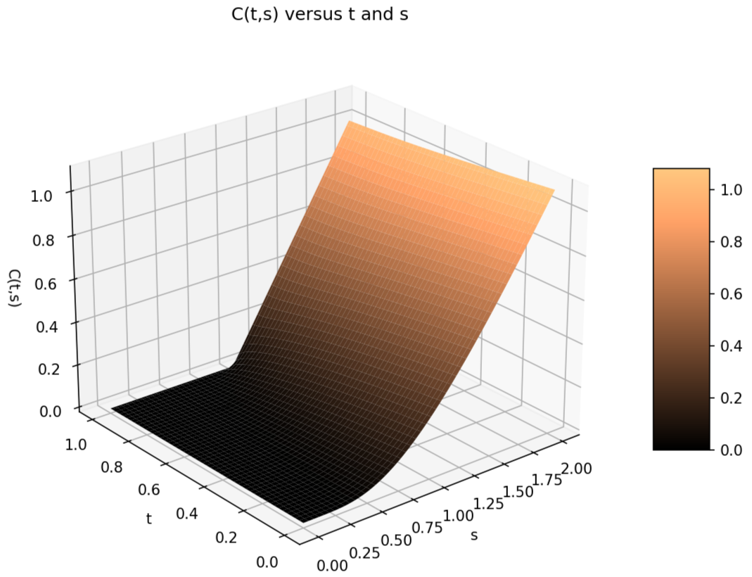

The plot of P(t, s) as a smooth surface above the (t, s)-plane is as follows:

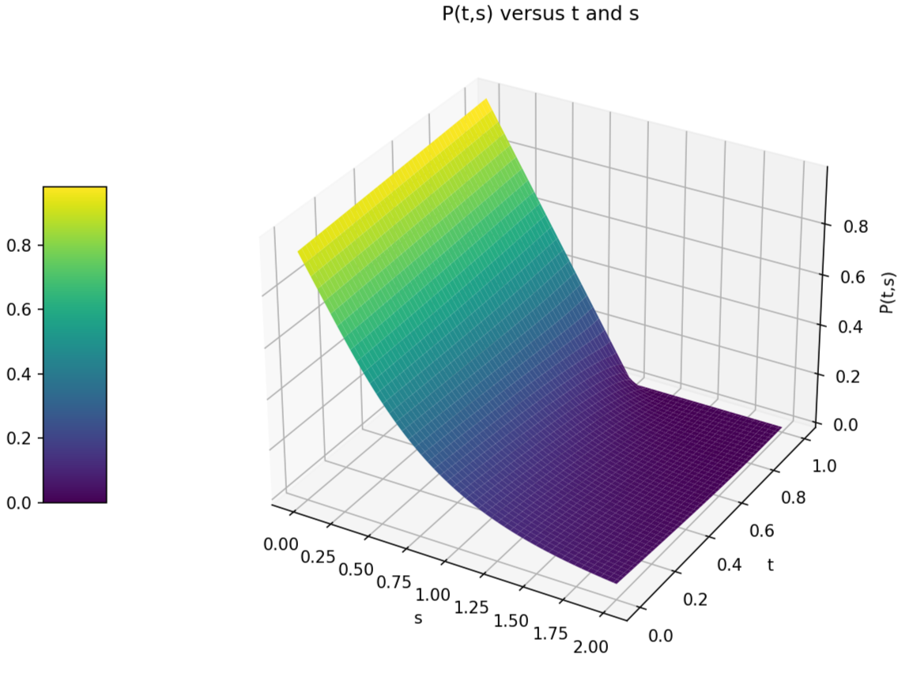

Question 4:

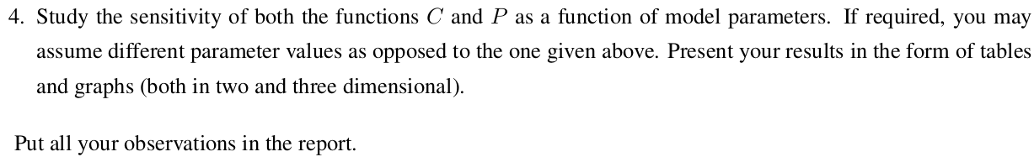

When some particular values of parameters are required, those values are taken from the following:

s = 0.8, t = 0, T = 1, K = 1, r = 0.05, σ = 0.6

The other parameter values are varied accordingly.

Variation of C and P with s, the price of underlying asset:

Already done in Question numbers 2 and 3.

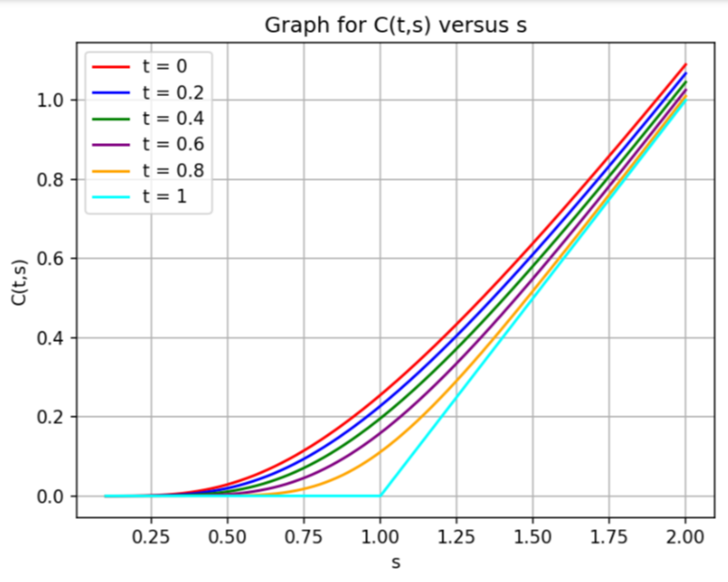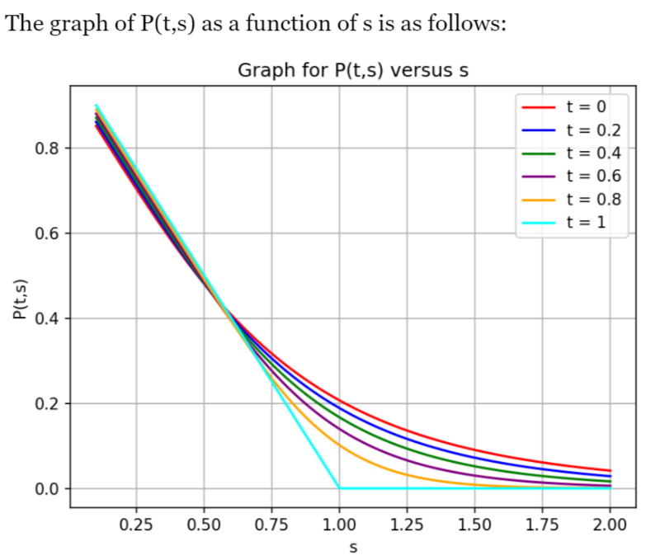

Variation of C and P with maturity time T:

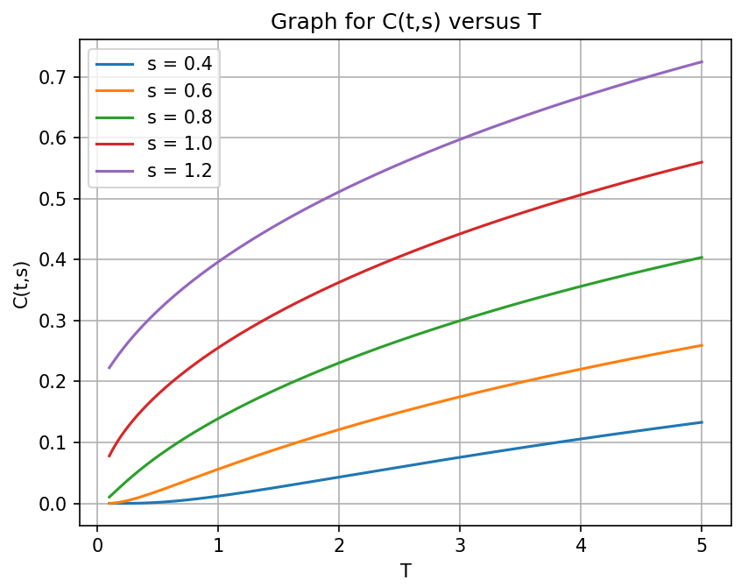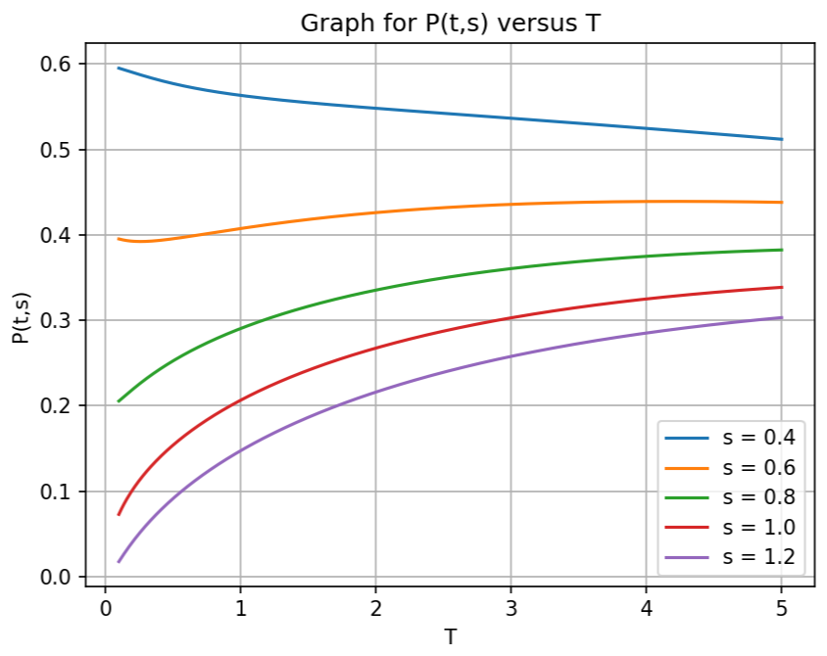

With parameter values as: s = 0.8, t = 0, K = 1, r = 0.05 and σ = 0.6,

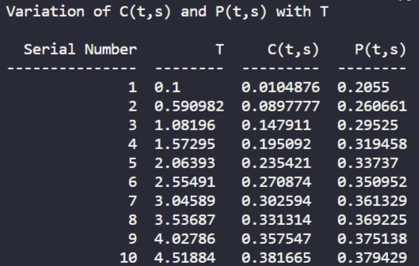

Variation of C and P with strike price K:

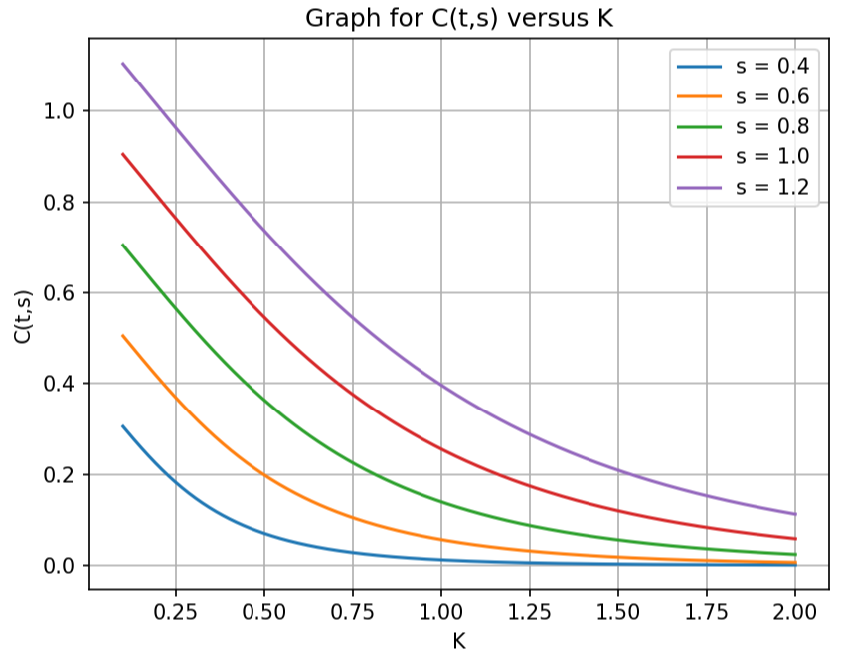

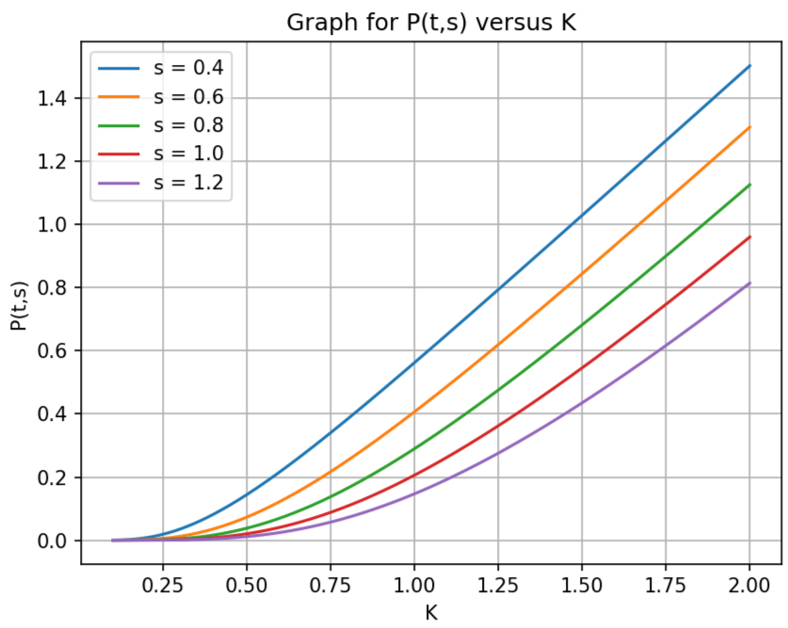

With parameter values as: s = 0.8, t = 0, T = 1, r = 0.05 and σ = 0.6,

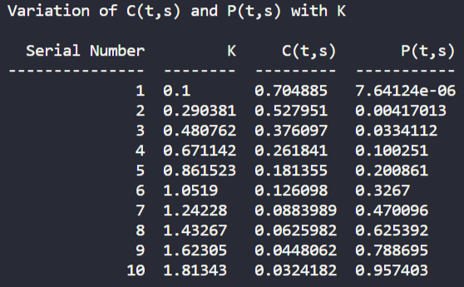

Variation of C and P with rate of interest r:

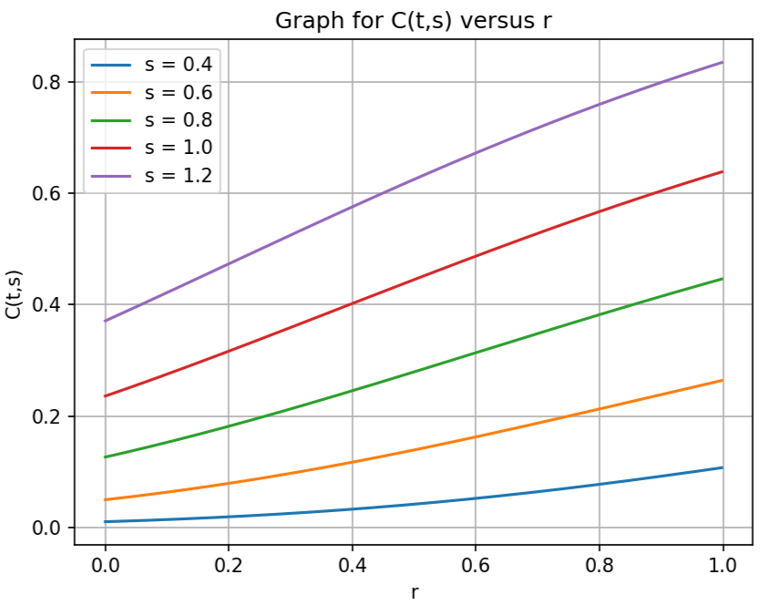

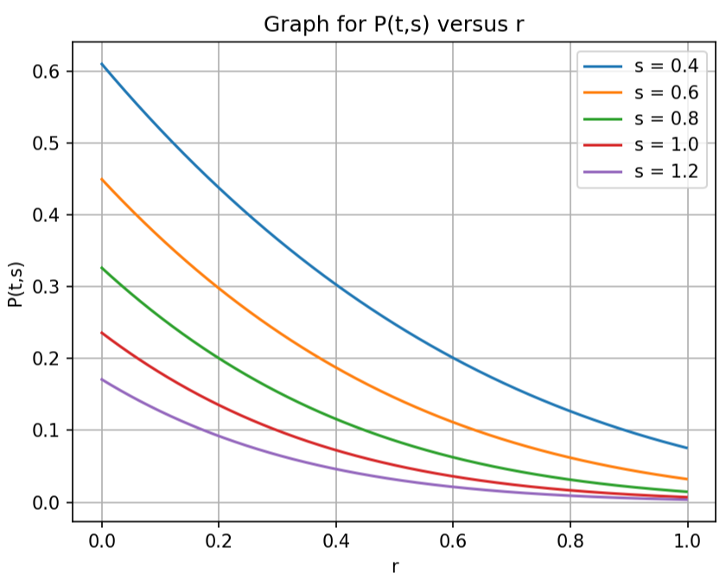

With parameter values as: s = 0.8, t = 0, T = 1, K = 1 and σ = 0.6,

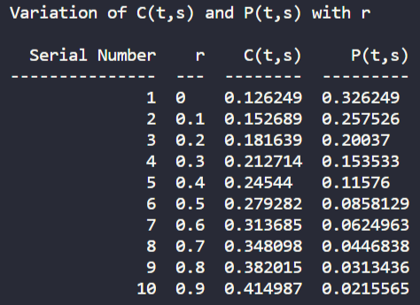

Variation of C and P with Volatility σ:

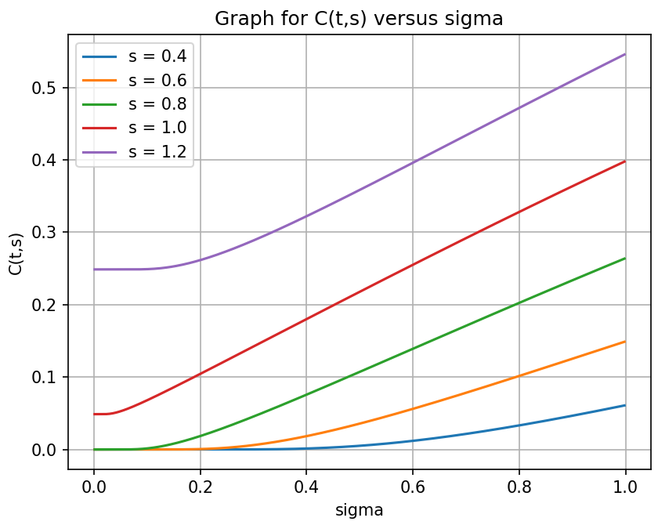

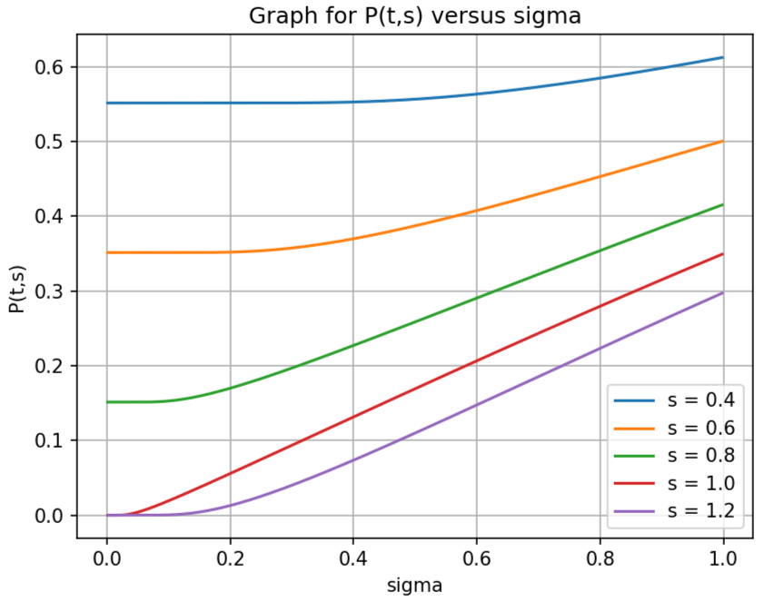

With parameter values as: s = 0.8, t = 0, T = 1, K = 1 and r = 0.05,

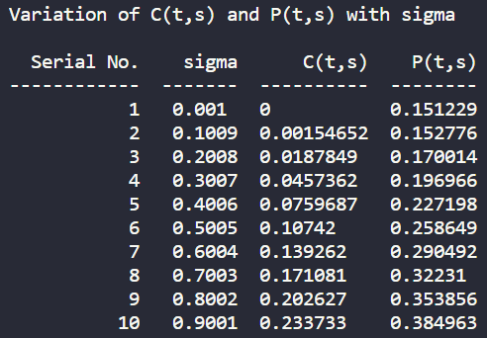

Variation of C and P with K and r:

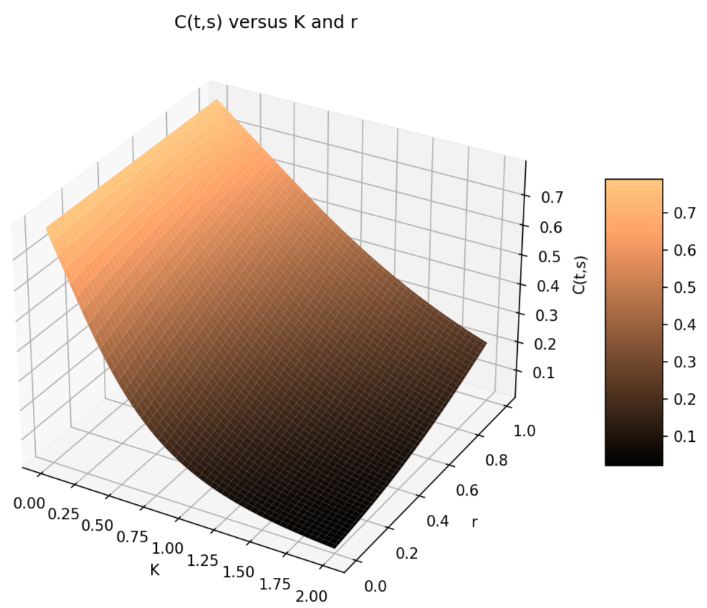

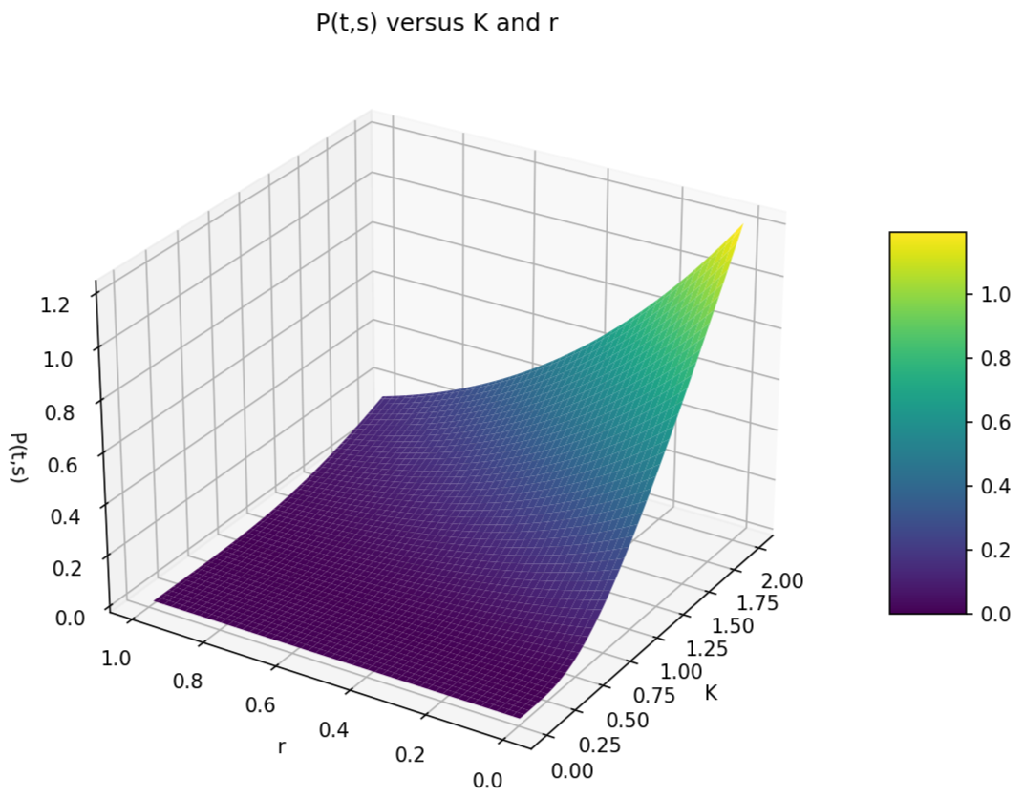

Variation of C and P with K and σ:

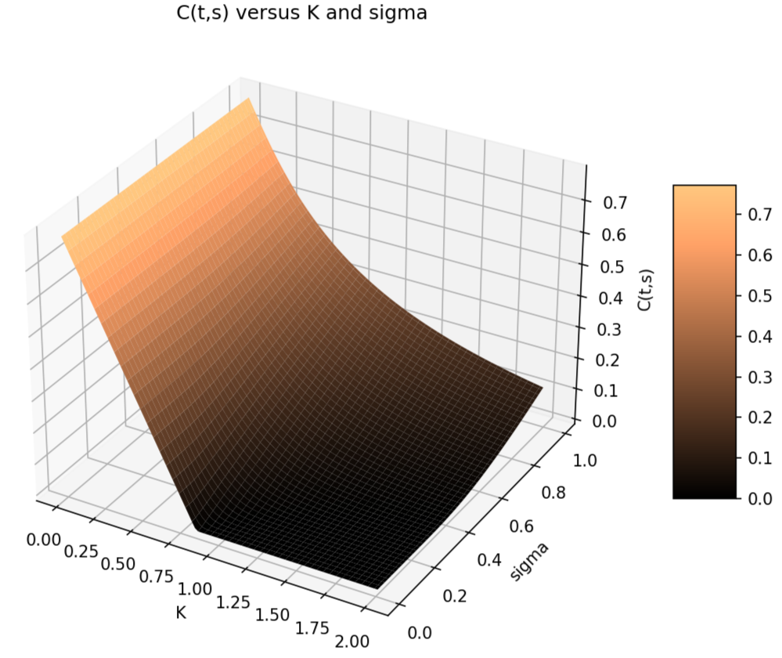

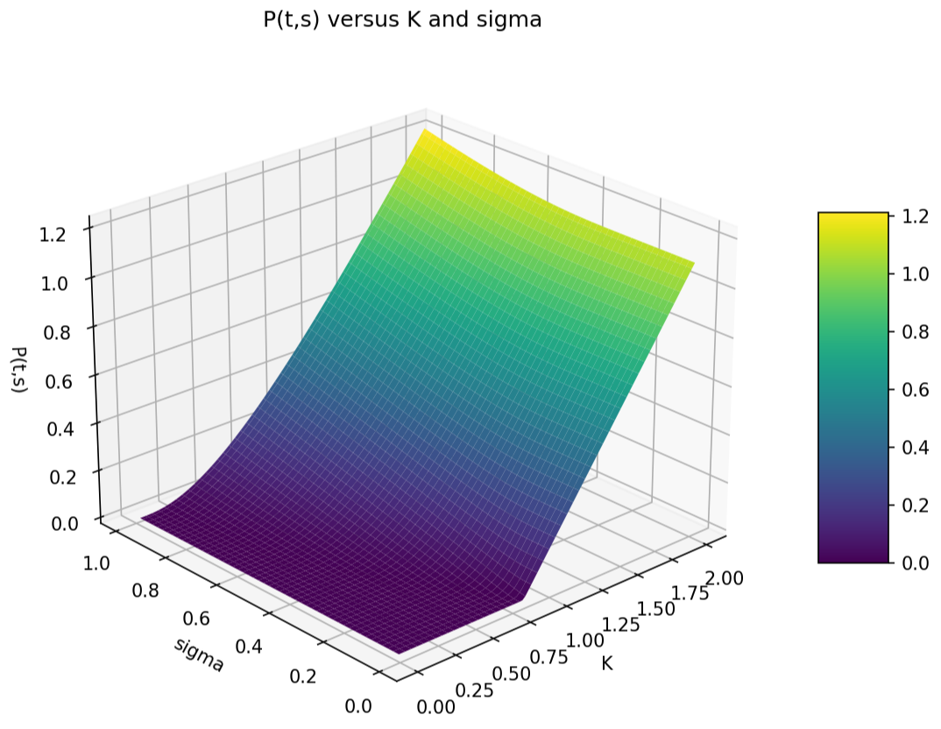

Variation of C and P with K and T:

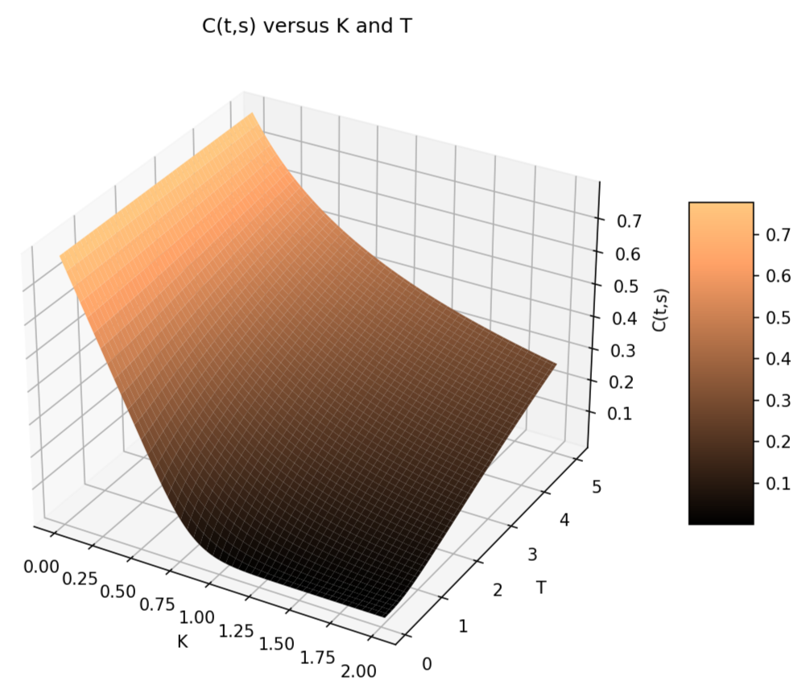

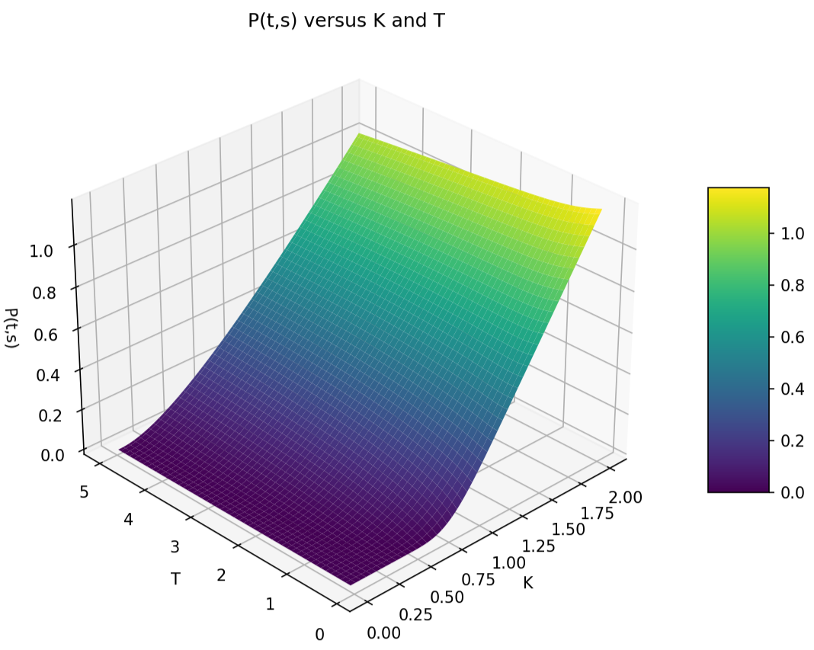

Variation of C and P with r and σ:

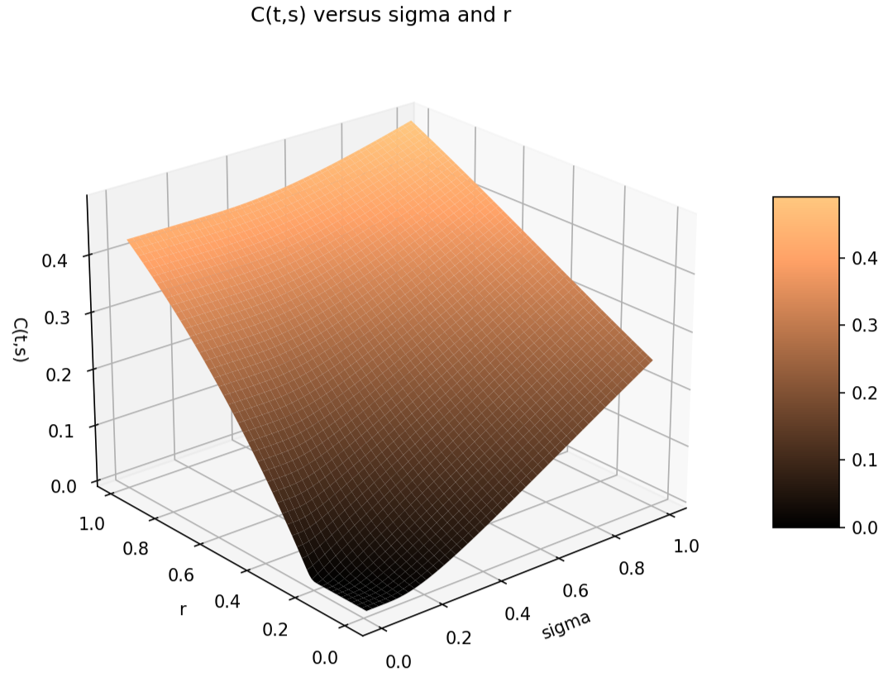

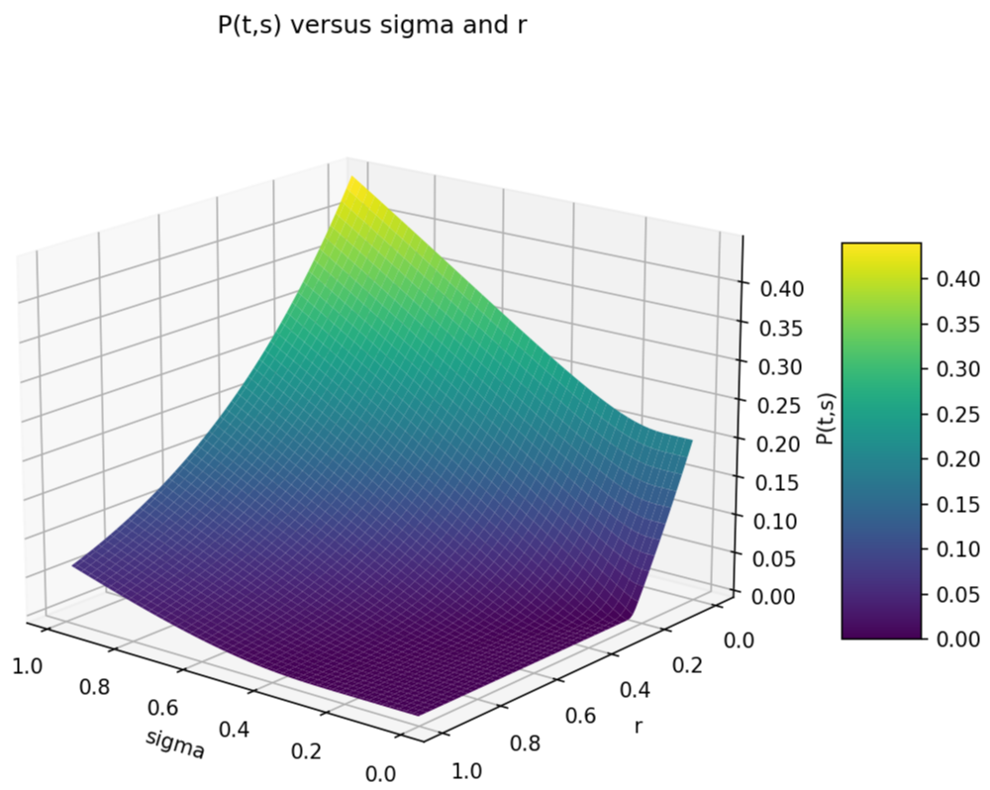

Variation of C and P with T and r:

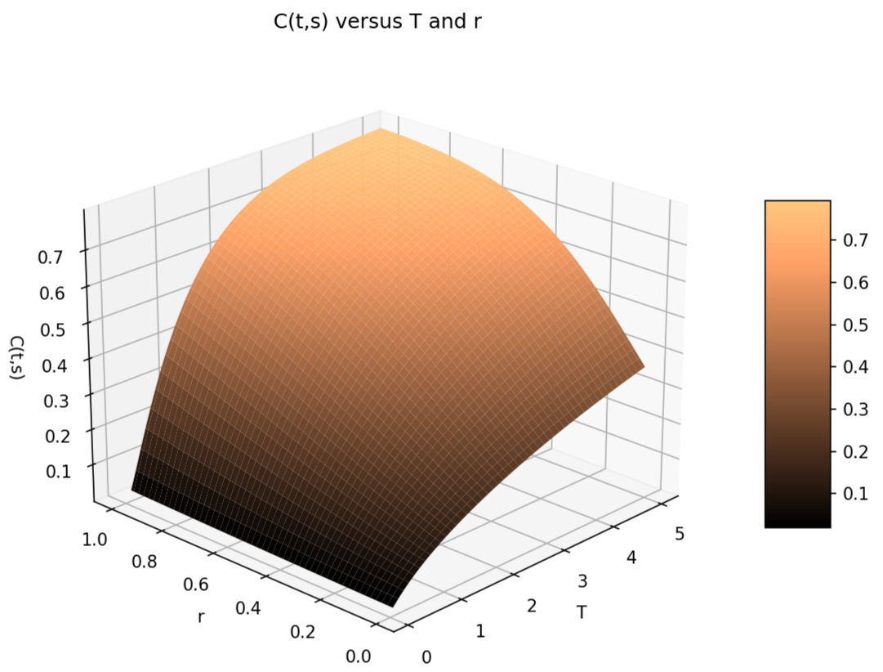

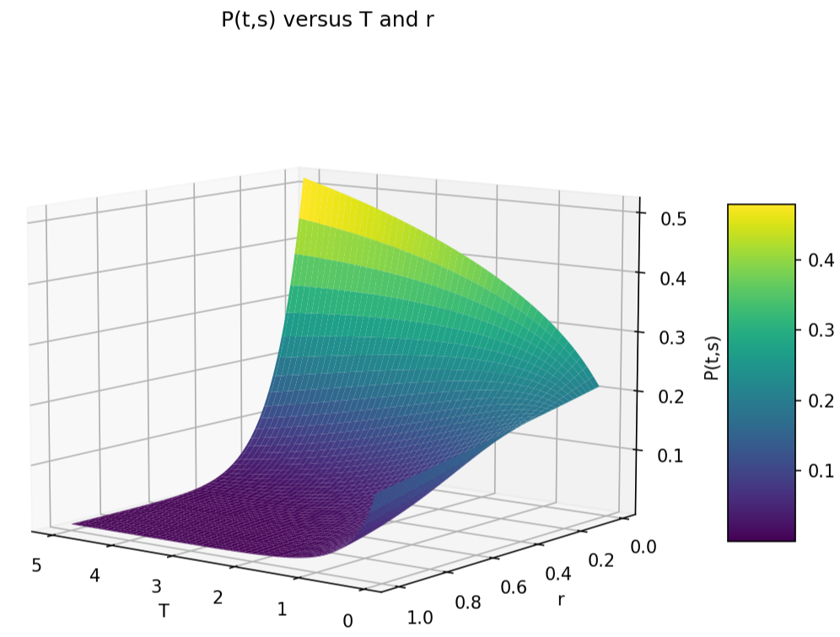

Variation of C and P with T and σ:

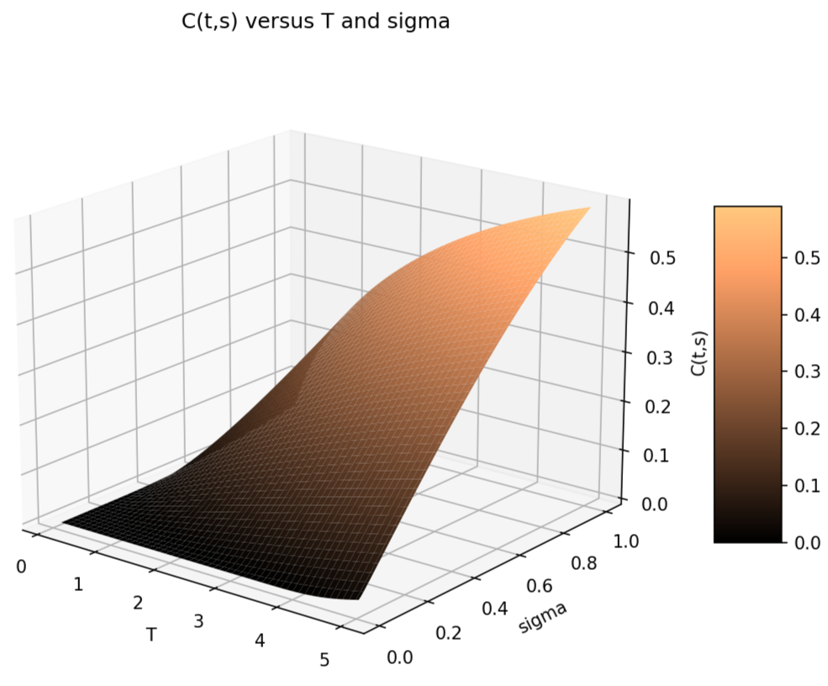

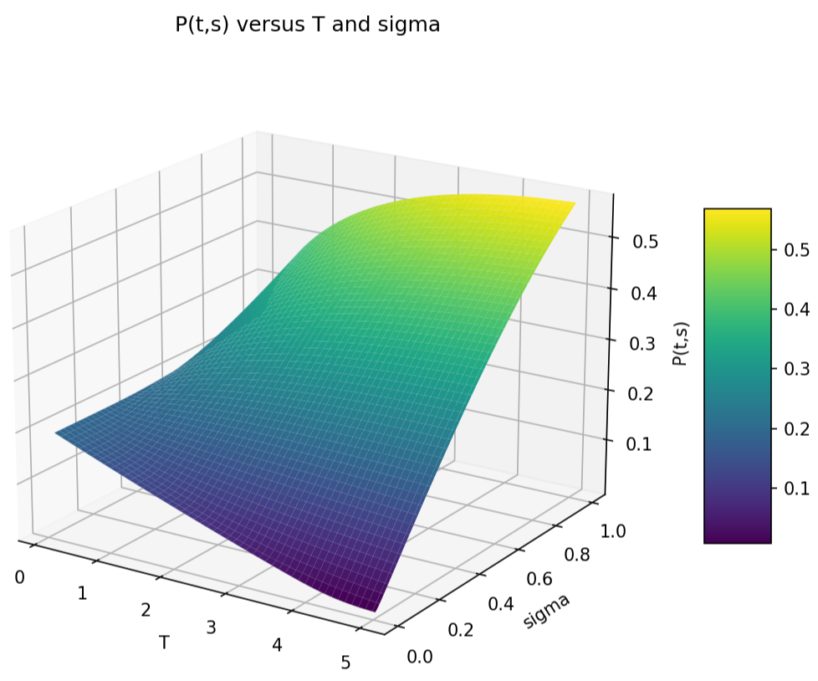

Variation of C and P with K and s:

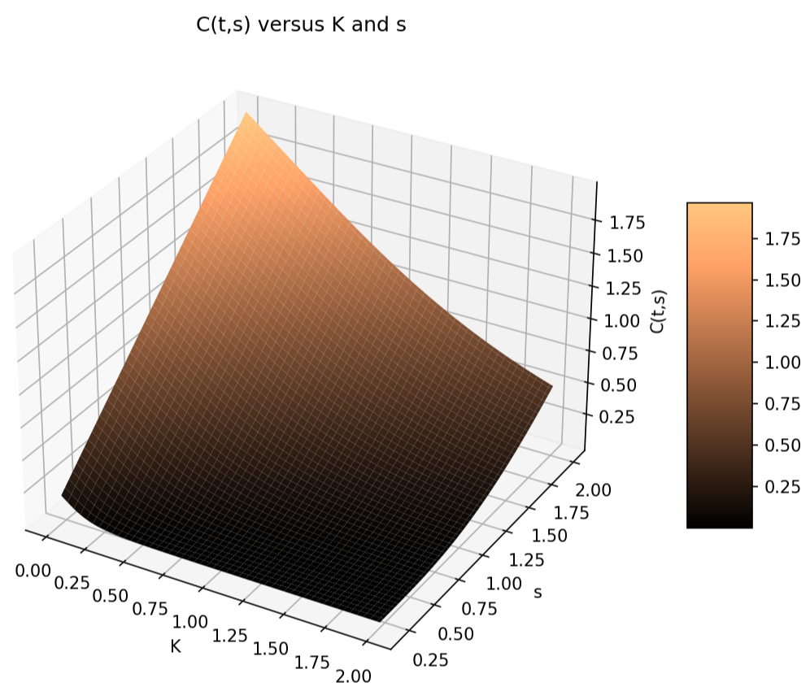

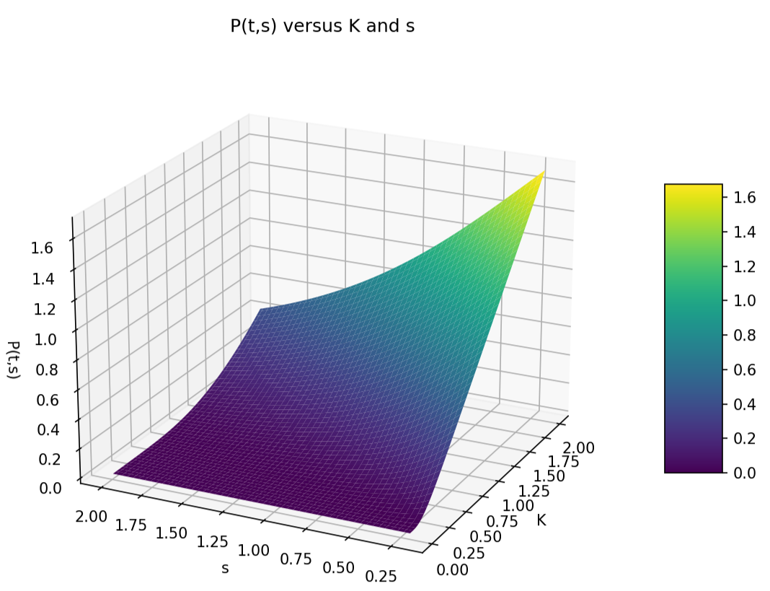

Variation of C and P with T and s:

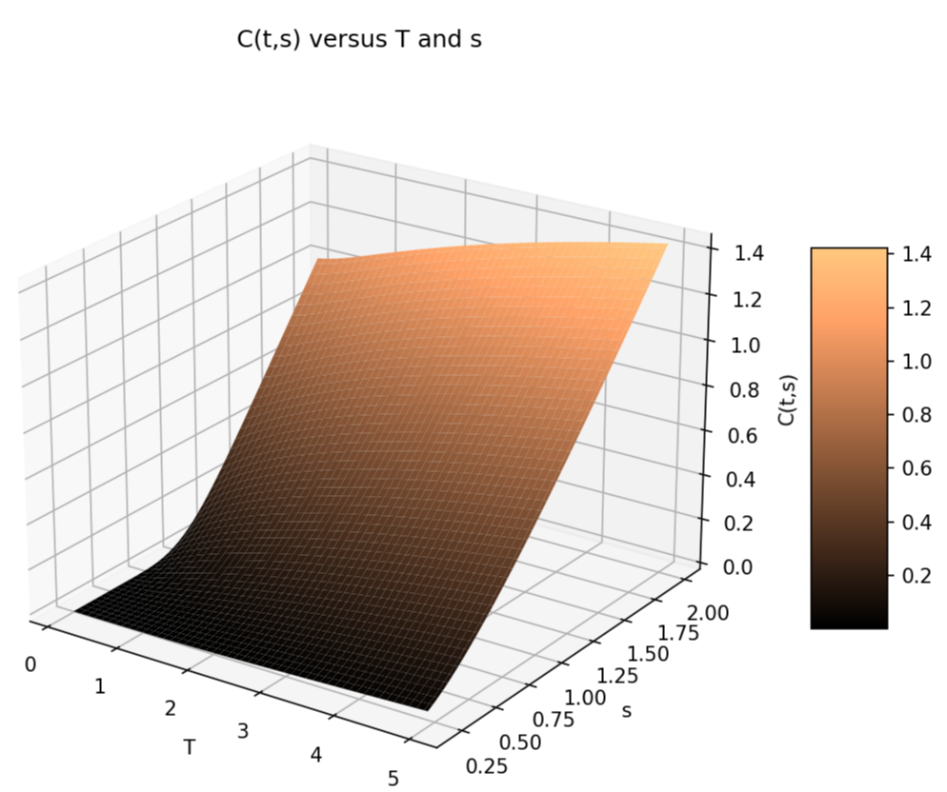

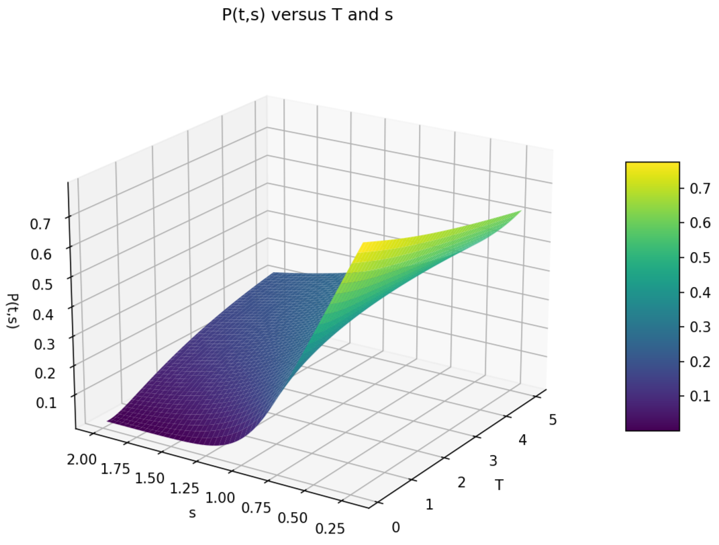

Variation of C and P with s and r:

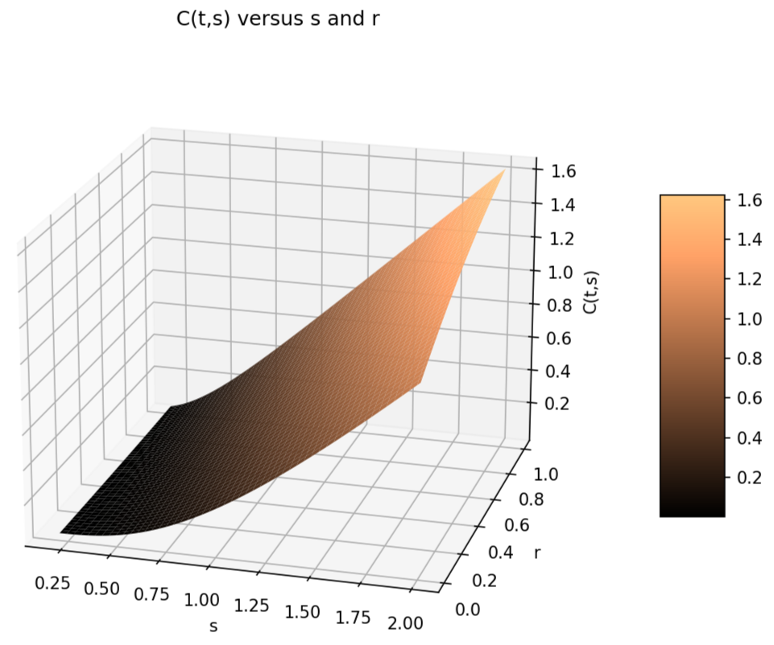

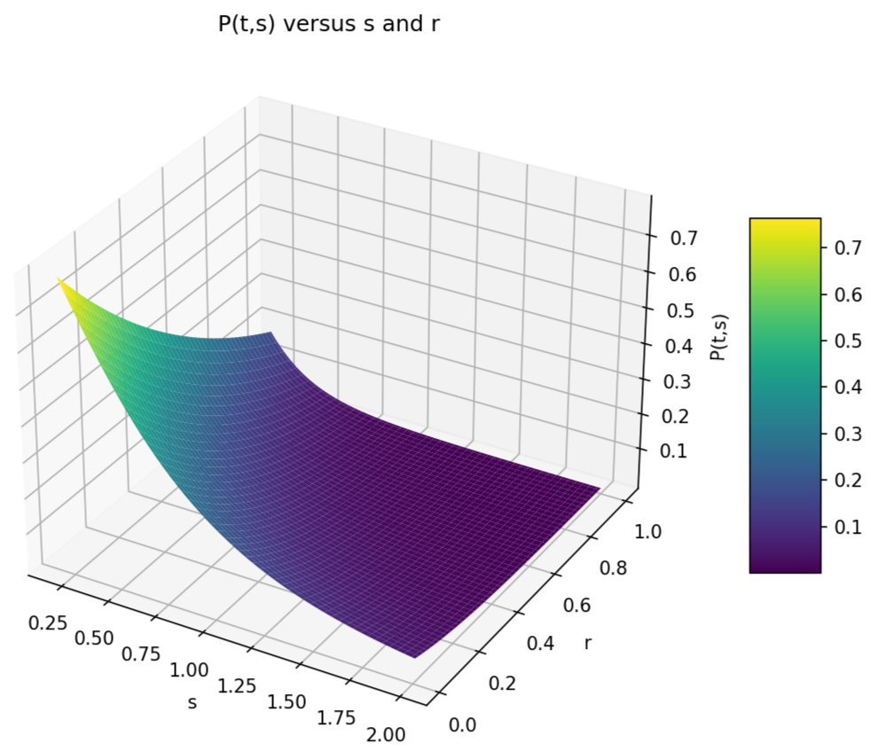

Variation of C and P with s and σ:

